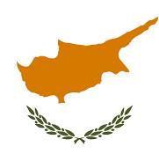

**56th WACA AGA — Pre-AGA Tour**

**SIGHTS OF CYPRUS**

**26–30 September 2025**

**PROGRAMME**

**Day 1: 26 September**

Individual arrivals at Larnaca International Airport.

Meet and assist at the Airport and transfer to the 4-Star Sun Hall Hotel, Larnaca.

Day at leisure.

Dinner at the Hotel.

**Day 2: 27 September**

Breakfast at Hotel.

***Larnaca***

After breakfast we will start your journey with a visit to Lefkara village, famous for its lace and silver-making traditions. Stroll along the picturesque stone-paved streets and take beautiful pictures. Next, stop at one of the most scenic places in Larnaca: a famous salt lake.

Lunch in Larnaca.

In the afternoon we will visit Hala Sultan Tekke Mosque, then navigate Finikoudes Promenade and discover the Church of Saint Lazarus, where you can touch holy relics, wash your face with holy water and pray for cures for various diseases.

Return to the Hotel for dinner.

**Day 3: 28 September**

Breakfast at the Hotel.

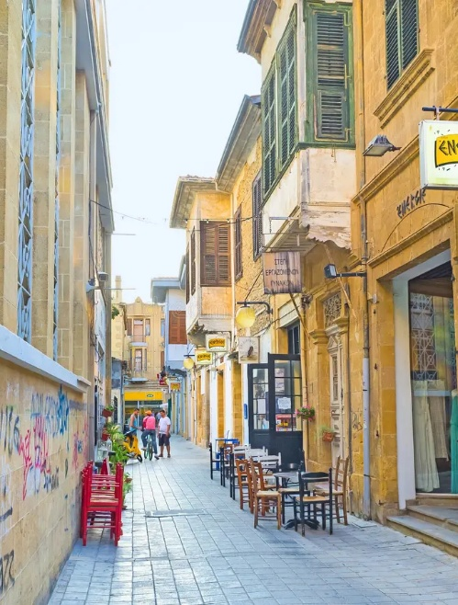***Nicosia***

Today we will visit Nicosia which is the only capital city in the world that is divided into two parts. The Green Line is the informal name for the UN-controlled buffer zone between Greek Cypriot, South Nicosia and Turkish Cypriot, North Nicosia.

Inside the old city with its Venetian walls, our first stop will be at the Cathedral of St. John and then we will proceed on foot *(weather permitting)* through the narrow streets of the old quarter until we reach the “Laiki Geitonia” with its colorful cafes, taverns and shops.

There will then be free time to explore the city centre around Eleftheria Square the city’s largest civic plaza that was designed to host festivals and public events.

Lunch will be taken in city centre and then there will be an opportunity to do some shopping before a visit to the museum.

Return to the Hotel for dinner.

**Day 4: 29 September**

Breakfast at the Hotel

***Limassol***

The second largest city on the island is Limassol. With a knowledgeable local guide we will discover Limassol's history and culture and experience the out-of-the-box Paradox Museum and explore thousand years’ old ancient sites.

Being the island’s maritime capital, Limassol is the main commercial and business port and also boasts an exclusive, recently built, modern marina. This vibrant and lively city has something for every taste, from significant archaeological treasures to interesting shopping spots and countless dining options.

Our first stop will be at the 13th century Kolossi castle which is a fine example of medieval military architecture.

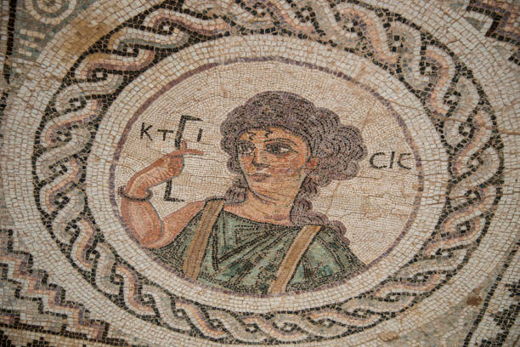Next is the archaeological site of the ancient kingdom of Kourion. In the Roman era, Kourion was one of the island’s most important city kingdoms which you can still experience through its significant remains. You will be able to marvel at the magnificent Greco-Roman theatre and the fine mosaic floors in the “House of Eustolios”, the “House of Achilles” and the “House of the Gladiators” as well as the remains of the Roman Agora, the sumptuous public baths and the imposing early Christian cathedral of the city.

Lunch will be taken back in Limassol.

The excursion will then return to the Hotel for Dinner.

**Day 5: 30 September 2025**

Breakfast at the Hotel.

A group transfer to Larnaca International Airport and conclusion of the package.

**Package Details**

**Date:** 26–30 September 2025.

**Cost:** USD 875.00 per person based on double occupancy. Single occupancy supplement USD 300.00.

**Registration Deadline:** 15 June 2025.

**Registration Form:** can be downloaded from the Events section of the WACA website [www.waca.org](http://www.waca.org) or requested by e-mail from Mr. Keith Miller, WACA Administration Manager at [wacaworld@outlook.com](mailto:wacaworld@outlook.com).

**Payments:** a deposit of USD 400.00 per participant is required to be confirmed on the package.

The deposit can be made by cheque, money order or bank draft in United States dollars made payable to the World Airlines Clubs Association and sent with the duly completed Registration Form to: World Airlines Clubs Association, c/o Mr Keith Miller, 644 Westwood Avenue, Dorval, Quebec, Canada H9P 2M5.

A deposit can also be made by bank transfer to WACA’s bank account as follows:

Bank of Montreal, 2005 Peel Street, Montreal, Quebec, Canada H3A 1T7.

Account name: World Airlines Clubs Association.

Account number: 4600-790.

Transit number: 01581-001.

Swift code: bofmcam2.

*It is most important to note that bank transfer charges for* ***both the issuing and receiving banks*** *must be borne by the participant.* *WACA’s bank charges USD 16.00 for each transfer received.*

The balance of payment can be made by one of the options above and must be sent by 22 August 2025 at the latest.

Regretfully, WACA does not have the capability to accept payments by credit card. Payment by PayPal is also not an option due to the high service charge incurred.

*Note: deposits are subject to a USD 50.00 cancellation fee up to 1 June 2025. No deposit will be refunded after that date.*

**Package Includes**

* Four night’s accommodation based on double occupancy at the 4-Star Sun Hall Hotel.
* Four breakfasts, three lunches and four dinners.
* All tours as outlined above in air-conditioned coaches with English speaking guides.
* WACA fee: USD 20.00 per participant.
* Transfer on arrival and departure: airport/hotel/airport.

*(continued)*

***Package Details (continued)***

**Package Excludes**

* Airfares.
* Personal expenses, e.g. laundry, telephone calls, Internet connection, etc.
* Meals, drinks, optional tours, etc. unless specified in the programme.
* Gratuities for guides and drivers.
* Travel, cancellation and personal insurance. ***Please obtain emergency medical and trip cancellation insurance.***
* Any other miscellaneous items as applicable.

*Should you have any questions about the pre-AGA tour, or require any further details, please send an e-mail to Maga Ramasamy:* [*maga@intnet.mu*](mailto:maga@intnet.mu).