**56th WACA AGA — Post-AGA Tour**

**HIGHLIGHTS OF SICILY**

**5–8 October 2025**

**PROGRAMME**

**Day 1: October 5th**

Morning. Public ferry boat from Valletta to Pozzallo *(bus included in order to arrive at Valletta).*

Arrival in Pozzallo. Meet your tour leader and the private bus that will be at your disposal for the whole journey.

Departure from Pozzallo to Syracuse.

Lunch at a restaurant on the way to Syracuse.

In the afternoon meet your half-day private guide for a walking guided tour of Syracuse.

The city of Syracuse is located in one of the most beautiful inlets on the Mediterranean. It is a vital and dynamic city, worthy of its great past, and in 2005 was duly recognised as a UNESCO World Heritage Site. A visit to Syracuse is a journey back in time and to discover the wonderful beauty of the natural environment in which the city is immersed. Syracuse has given rise to great figures of the cultural and artistic history of the Mediterranean and still has a very lively intellectual life. We will also visit its famous open air Greek theatre.

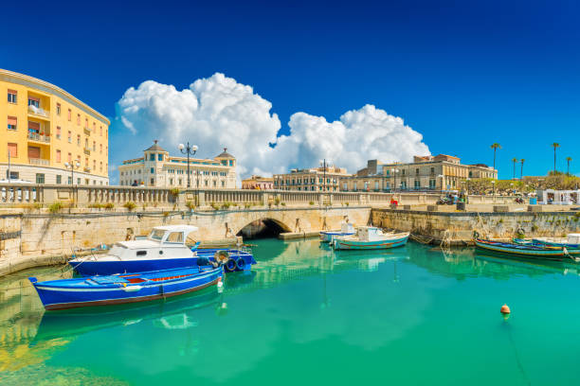

We will then drive to Catania where we will stay for three nights at the 4-Star Grand Hotel Baia Verde.

Dinner with one glass of wine and half-bottle of water included.

**Day 2: October 6th**

Breakfast at the Hotel.

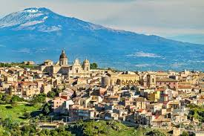Meet your half-day guide for a discovery of Catania.

Once in the city, your first stop will be the Ursino Castle, founded by Frederick II of Swabia in the 13th century and a rich civic museum today *(external visit).* As you stroll through the streets of the centre, keep an eye out for the black and white buildings that overlook large squares. Firstly, Palazzo Biscari, the biggest noble residence in Catania. Nearby you will find the elegant Teatro Massimo, dedicated to Vincenzo Bellini, an illustrious son of this city.

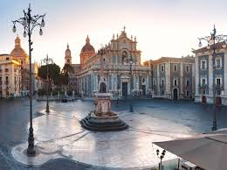Take a break at Villa Bellini to see one of the two oldest gardens as well as one of the four main parks in Catania.

Finally, visit the Cathedral of Catania in whose wonderful square “O Liotru”, the elephant symbol of the city, dominates and take a walk along Via Etnea, the most important street that stretches for 3 km.

We will also visit the Pescheria of Catania, the ancient and noisy morning fish market that can be reached by climbing a volcanic rock staircase.

At the end of the guided tour we will take lunch at a local restaurant.

Return to the Hotel for dinner with one glass of wine and half-bottle of water included.

**Day 3: October 7th**

Breakfast at the Hotel and then departure towards Mount Etna.

Discover one of the most active volcanoes in the world with our Etna Jeep Tour. We will drive on board a Land Rover 110 an head in the direction of the volcano. We will discover idyllic Sicilian villages and some of Sicily’s most famous wine growing regions and whilst gaining altitude you will learn a lot about the country, the population and their culture.

*(continued)*

***Day 3 (continued)***

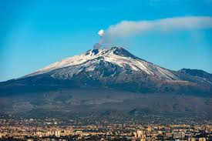You will certainly remember the impressive play of colours of the black lava and the extraordinary vegetation on Mount Etna. As we pass by the lava flows of recent years, we will see centuries-old forests and we will stop at some of the most beautiful places on Mount Etna. During an easy but impressive hike of approximately 45 minutes on the craters in the surrounding area you will see the unique landscape with the old and new lava. Like the speleologists you will be equipped with helmets and flashlights to explore one of the famous lava caves on foot with your guide. These caves were created by a lava flow and they still have special properties. Centuries ago residents close to Mount Etna used these caves for the ice production.

Finally, a **typical Sicilian lunch** awaits you in a mountain chalet on **Mount Etna**. With traditional antipasti, pasta of the season and a delicious dessert, accompanied by water, Sicilian wine and a good coffee. You will get to know the local cuisine.

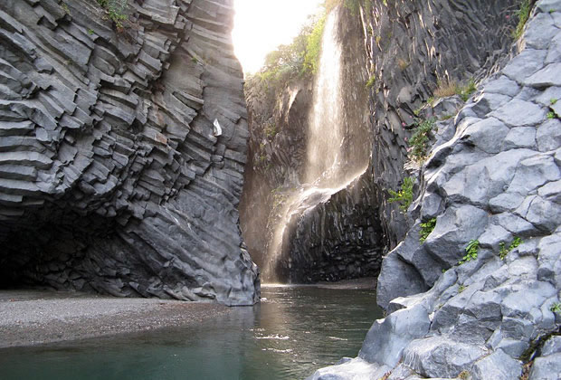Well-rested, the adventure continues to the famous **Alcantara River**. Along the way we drive through the renowned Sicilian Mountain village “Castiglione di Sicilia.” There, you will get to see one of Sicily’s most famous wine-growing regions and enjoy an impressive view along the wine route. You will then experience the beauty of the Gole dell’Alcantara which were formed thousands of years ago in the north of the volcano by a lava flow. A magical place awaits you with spectacular basalt rock formations and small waterfalls of the Alcantara River.

After an exciting day full of new experiences, we return to your Hotel.

Dinner with one glass of wine and half-bottle of water included.

**Day 4: October 8th**

Breakfast at the Hotel.

Departure towards Pozzallo.

Public ferry boat to Valletta.

Departure and end of all services. *A group transfer to the Malta International Airport at a cost of USD 10.00 per person will be arranged providing there is a minimum of 25 participants.*

**Package Details**

**Date:** 5–8 October 2025.

**Cost:** USD 1,200.00 per person based on double occupancy. Single occupancy supplement USD 200.00.

**Registration Deadline:** 15 June 2025.

**Registration Form:** can be downloaded from the Events section of the WACA website [www.waca.org](http://www.waca.org) or requested by e-mail from Mr. Keith Miller, WACA Administration Manager at: [wacaworld@outlook.com](mailto:wacaworld@outlook.com).

**Payments:** a deposit of USD 400.00 per participant is required to be confirmed on the package.

The deposit can be made by cheque, money order or bank draft in United States dollars made payable to the World Airlines Clubs Association and sent with the duly completed Registration Form to: World Airlines Clubs Association, c/o Mr Keith Miller, 644 Westwood Avenue, Dorval, Quebec, Canada H9P 2M5.

A deposit can also be made by bank transfer to WACA’s bank account as follows:

Bank of Montreal, 2005 Peel Street, Montreal, Quebec, Canada H3A 1T7.

Account name: World Airlines Clubs Association.

Account number: 4600-790.

Transit number: 01581-001.

Swift code: bofmcam2.

*It is most important to note that bank transfer charges for* ***both the issuing and receiving banks*** *must be borne by the participant.* *WACA’s bank charges USD 16.00 for each transfer received.*

The balance of payment can be made by one of the options above and must be sent by 22 August 2025 at the latest.

Regretfully, WACA does not have the capability to accept payments by credit card. Payment by PayPal is also not an option due to the high service charge incurred.

*Note: deposits are subject to a USD 50.00 cancellation fee up to 1 June 2025. No deposit will be refunded after that date.*

**Package Includes**

* Group transfer from the Radisson Blu Resort to Valletta.
* Round trip on public ferry Valletta/Pozzallo/Valletta.
* Three night’s accommodation based on double occupancy at the 4-Star Grand Hotel Baia Verde.
* Three main meals daily: breakfast, lunch and dinner.
* All tours as outlined above, in air-conditioned coaches, and site visits with English speaking guides.
* Site entrance fees where applicable and Syracuse city tax.
* WACA fee: USD 20.00 per participant.

*(continued)*

***Package Details (continued)***

**Package Excludes**

* Airfares.
* Personal expenses, e.g. laundry, telephone calls, Internet connection, etc.
* Meals, drinks, optional tours, etc. unless specified in the programme.
* Gratuities for guides and drivers.
* Travel, cancellation and personal insurance. ***Please obtain emergency medical and trip cancellation insurance.***
* Any other miscellaneous items as applicable.

*Should you have any questions about the post-AGA tour, or require any further details, please send an e-mail to Maga Ramasamy:* [*maga@intnet.mu*](mailto:maga@intnet.mu).